**WhatsApp Pay**

**Overview and Summary**

WhatsApp is a messaging and Voice over IP (VoIP) service owned by Facebook. It allows users to send text and voice messages, make voice and video calls, and share images, documents, and other media. WhatsApp runs on mobile devices but is also accessible from desktop computers. WhatsApp has over 2 billion users worldwide as of today. It has become the primary means of electronic communication in multiple countries across multiple continents, including Latin America, the Indian subcontinent, and large parts of Europe and Africa.

Today across the globe people are moving to digital payment services such as Google Pay, PayPal, and others. Mobile wallets are in massive demand. The transaction value of the global mobile payments market was USD 3714.5 billion in 2019 and is expected to reach USD 12,407.5 billion by 2025, registering a CAGR of 23.8%. WhatsApp being one of the leading mobile messaging apps wants to get a slice of this growing digital payment market.

WhatsApp has decided to take the plunge into this digital payment market. They have launched a new feature namely, WhatsApp Payments to be known as WhatsApp Pay in Brazil in June 2020. WhatsApp promises to disrupt the global digital payments ecosystem with WhatsApp Pay.

WhatsApp will integrate the customer’s debit card or credit card into their app. That is, while chatting with your peers, you can transfer the money to them. There will be no separate app that the customers need to download to access this payment feature. This feature would be provided to users as an update in the existing WhatsApp messaging app. The user can use WhatsApp pay feature by updating the WhatsApp messaging app.

They are banking on the fact that the popularity of WhatsApp and the sheer number of WhatsApp users (2 billion) will be an added advantage over other payment apps. Now, they have launched the feature in Brazil, and it will be followed by a launch in India and then the rest of the world.

**Project Task:**

1. Identifying stakeholders – Create a list of stakeholders (as taught in Business Analysis Planning and Monitoring Knowledge Area)

Ans. **STAKEHOLDERS**

| **ACTOR** | **What he can do on the Software Created** |
| --- | --- |
| WhatsApp users | * Integrate Debit Card into app * Integrate Credit Card into app * Transfer money to peer (contact list) * One clicks payment * Generate a security pin * Raise Money Request * Accept money request/Consent to pay * Scan QR code |
| Banks | * Authenticate the request * Reject the request in case of invalid details or insufficient balance * Issuer bank debit the amount from customer’s account * Acquirer bank credit the amount in customer’s account |
| Credit card providers | * Authenticate payment through pin * Verify credit card limit * Accept the amount from issuer bank * Settle the amount with acquirer bank. * Execute fund transfer |
| Bank (debit card provider) | * Authenticate payment through pin * Verify debit card amount * Accept the amount from issuer bank * Settle the amount with acquirer bank. * Execute fund transfer |
| Sponsor - Facebook | * Authorize and approve the need, scope and budget for initiative |
| Business Analyst | * Gather requirements * Elicit and collaborate with stakeholders - Propose solution and seek approval/sign off * Communicate requirements to operational support and implementation team * Review solution design and get stakeholder signoff |
| Operational Support | * Responsible for day to day management and maintenance of system |
| Implementation SME | * Design /Lead requirement architecture * Lead and review the development of WhatsApp pay System |
| Project Manager | * Serve as a facilitator and manage the work required to deliver a solution * Conduct scrum calls * Drive resource estimation, task and effort estimation and publish progress report; highlighting risks if any |

1. Identify risks in this new feature (Identify them using the Strategy Analysis Knowledge Area)

Ans. **Risk Identification**

* Money sent to the wrong account
* System Hack
* User may forget security pin
* Incomplete/Delayed payments
* Anti Money Laundering

1. Do a SWOT analysis for WhatsApp Pay feature (SWOT – Strengths, Weaknesses, Opportunities and Threats). This is the SWOT Technique taught in class

**SWOT Analysis of WhatsApp pay**

Perform SWOT Analysis for the system.

**Strengths:** WhatsApp has 2 billion user worldwide and become the primary means of electronic communication in multiple countries across multiple continents, including Latin America, the Indian subcontinent, and large parts of Europe and Africa.

**Weakness:** Change in policies, Update app, More maintenance, Approvals, WhatsApp pay will use or not.

**Opportunity:** Capture the market easily, Make more profit, Less advertisement, Built trust, update the app,

Not more information required.

**Threat: Ethical hacking, Information leaked, Cyber-attack, Phishing, low server during update or maintenance, wrong transaction.**

**As-is Process Map**

Note – As WhatsApp is plunging into digital payment market to compete with other payment apps. Hence here I have covered as is process of a money wallet or existing digital service provider which require user to install a separate app

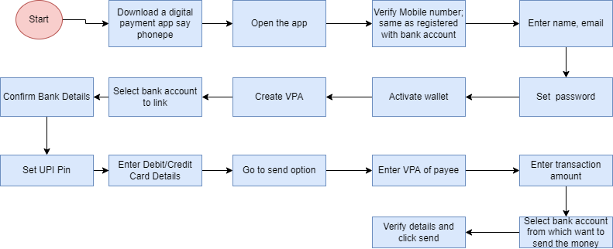

**Future Process Map**

Not quite sure if its correct to keep all WhatsApp users, senders, receivers can have a separate lane because all are WhatsApp users. Please advise

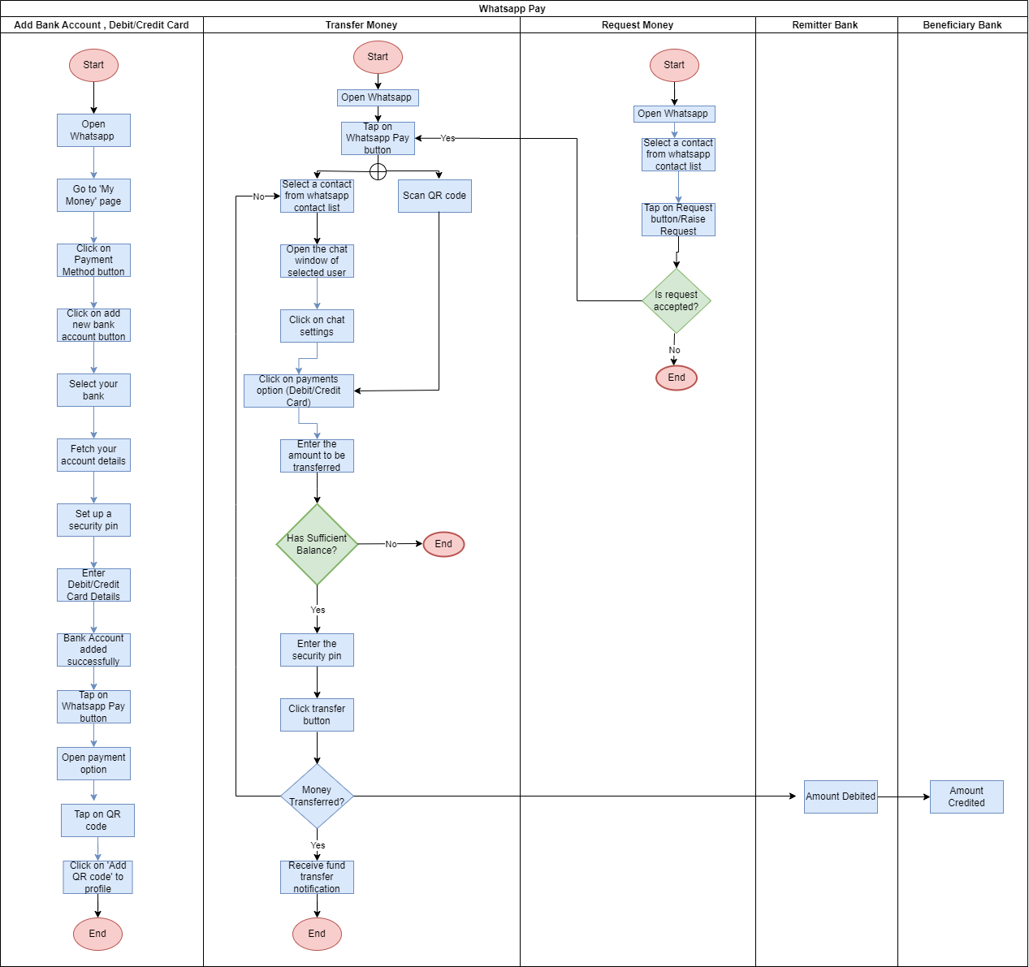

1. As a Business Analyst working on this project, find out the scope of this system. To find the scope you can use Use Case diagram (UML) or Context diagram

Ans. **SCOPE using Use Case Diagram (UML)**

Create a use case diagram including all the actors and processes for an end to end process of the system.

UML – Case diagram – To be done *– Yet to be covered in session.*

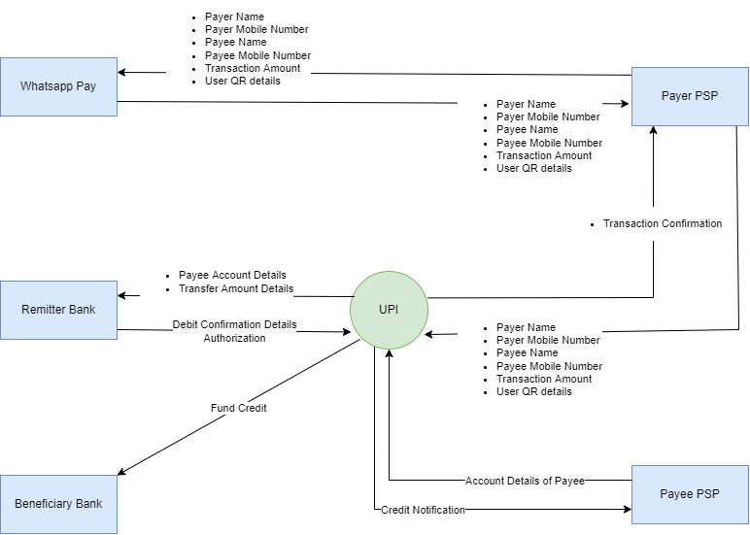

1. Write down the main features that need to be developed

|  |  |
| --- | --- |
| Users | Features |
| WhatsApp user | Add/update/delete bank account, Add/update/delete debit card, Add/update/delete credit card, Transfer Fund to contact, Generate a security pin, Payment notification, Raise money request, Accept money request, Cancel money request, authenticate transaction, maintain transaction history |

1. Write the in-scope and out-of-scope items for this software

Ans. **IN SCOPE**

* Add/update/delete bank account; multiple bank accounts
* Link debit or credit card
* Generate security pin to authenticate transactions
* Receive payment notifications
* Generate qr code
* Scan QR code,
* Transfer fund to family, friends, or relatives on WhatsApp contact list
* Request money from family, friends, or relatives on WhatsApp contact list

**OUT OF SCOPE**

* No mobile wallet
* Transaction from Group chat
* Transaction with non-WhatsApp users
* Transaction with unknown WhatsApp users; not in contact list

1. Write out the Business Requirements, both Functional and Nonfunctional Requirements

**Business Requirements:**

**Business Objective:**

* Have at least 1 million users use WhatsApp pay feature within the first 3 months of launch.
* Over 1 year of its launch have 30% of user base using WhatsApp pay.

**FUNCTIONAL REQUIREMENTS**

* Ability to add/update/delete bank account to WhatsApp account
* Integrate debit/credit card into app
* Ability to transfer money to contact list peer with valid bank account and card details
* Ability to transfer money via QR
* Ability to raise money request
* Ability to accept/reject money request
* View Transactions log history

**NON-FUNCTIONAL REQUIREMENTS**

* **Availability** – Available to use by upgrading the WhatsApp application
* **Scalability** – Scale up to a biggest market comprising 400 m consumers followed by rest of the world
* **Usability**: Self-explanatory and user-friendly interface. Once click payment
* **Compliance** - Comply with regulator policies, data security policy

1. Draw wireframes or mock screens for any 2 of the features namely book record creation and any other feature as deemed fit by the student. (Use the technique prototyping or wireframing that is taught in the training). You can use any of the wireframing tools like Microsoft PowerPoint, Microsoft Word, Balsamiq, Sketch, Adobe XD, Adobe Illustrator, Figma, UXPin, InVision Studio, InVision Freehand, or Moqups

**Screen Wireframes**

